Tania Cleary’s Top 5 picks – you’re never seen a year in politics like this before!

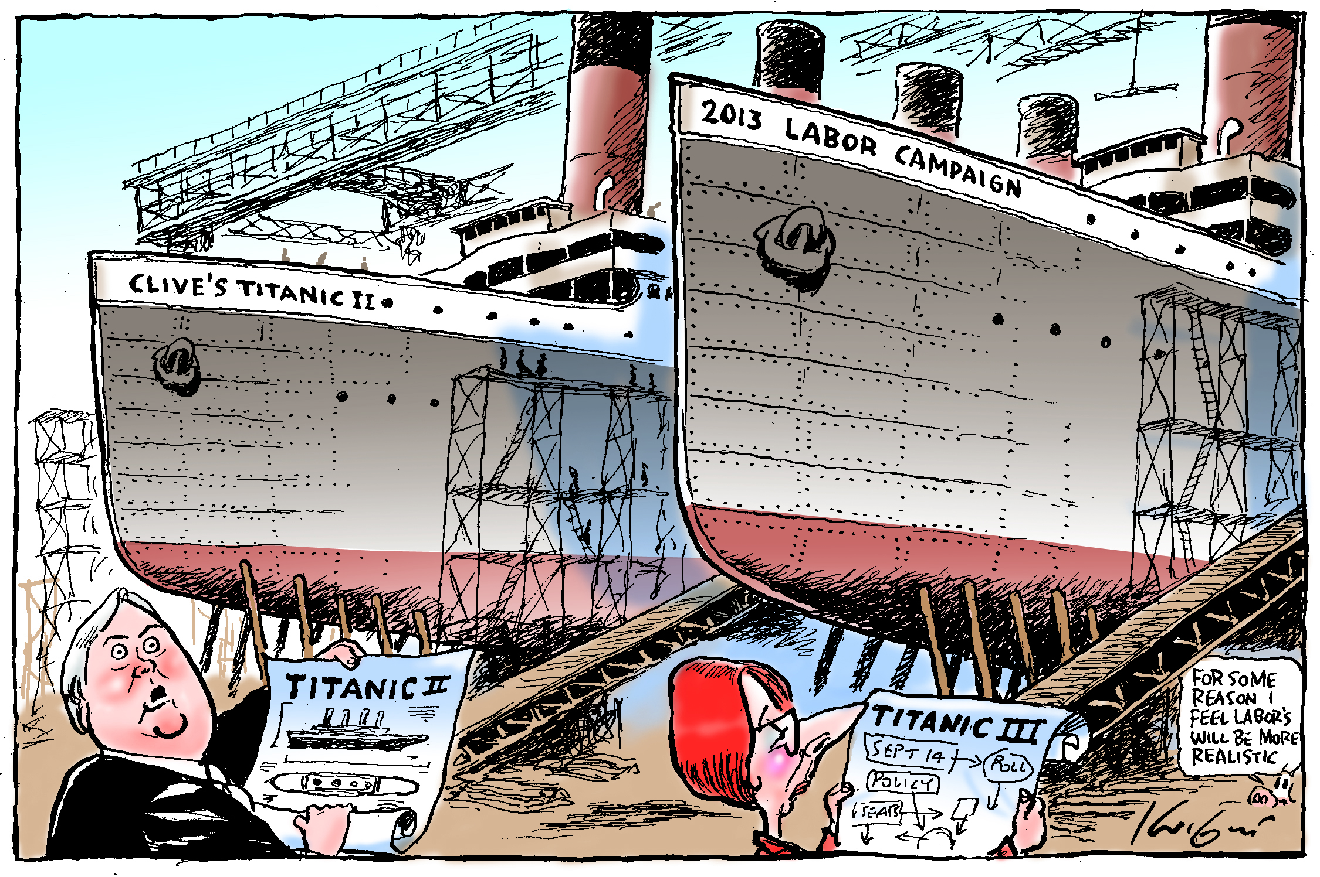 | Mark Knight's "Titanic II" is one of Tania’s favourites. What’s your favourite cartoon, let us know on Facebook or #BTL2013  ‘The cartoon is great political caricature as Clive Palmer and Julia Gillard are drawn looking over their respective plans. I like Clive Palmer's astonished look and Julia Gillard's over the top outline of the 14 September federal election campaign with its arrows pointing in all directions to polls, policy and seats. Essentially it's all about big ships, big visions, big ego's and in hindsight the bigger, bolder plan and bigger ego appears to have won.’  - Tania Cleary, Curator.
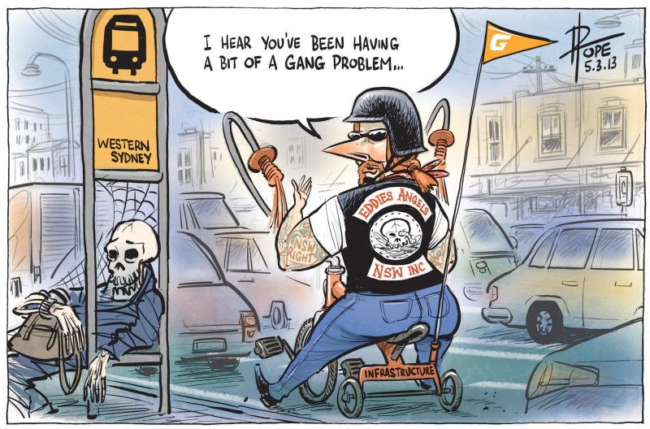 | David Pope's "Eddie’s Angels" is one of Tania’s favourites. What’s your favourite cartoon, let us know on Facebook or #BTL2013  ‘I like the way Pope manages to lampoon so many political issues: Eddie Obeid, bikies, criminal gangs, public transport and Julia Gillard. She wears the paraphernalia of the bikie including her 'NSW RIGHT' tattoo, her tricycle with its 'INFRASTRUCTURE' number plate, the traffic jam and the passenger waiting for the bus that clearly didn't arrive. A truly unique and grotesque cartoon.’  - Tania Cleary, Curator.
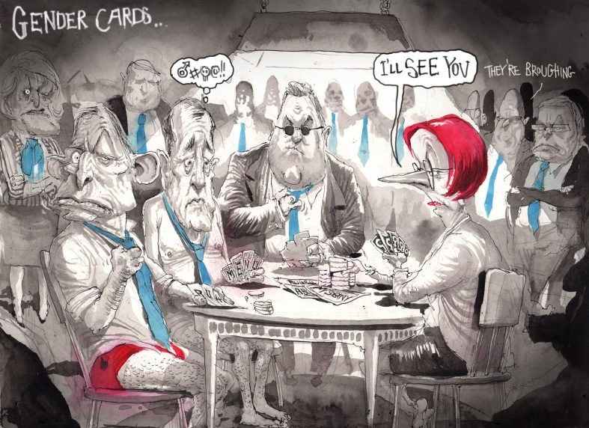 | David Rowe's “Gender Cards” is one of Tania’s favourites. What’s your favourite cartoon, let us know on Facebook or #BTL2013  ‘I think this is the most politically powerful and acerbic cartoon in the exhibition because of its subject matter and Rowe's use of political references is impressive: blue ties, the cards that spell RU4 and MENU, the awkward expressions on Tony Abbott's and Mal Brough's faces, Joe Hockey present but fully clothed, the watching crowd, Julia Gillard's challenge and the "they're broughing" line. I think that no-one in the cartoon would want to be reminded of this politically charged period.’  - Tania Cleary, Curator.
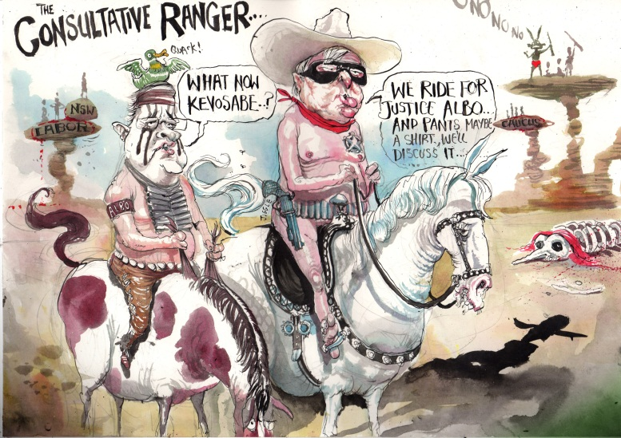 | David Rowe's “Consultative Ranger” is one of Tania’s favourites. What’s your favourite cartoon, let us know on Facebook or #BTL2013  ‘I smile every time I look at this cartoon because it is so cleverly constructed and so ridiculous. I like the "we ride for justice" line, the grand and desolate landscape that shows NSW Labor, Tony Abbott and the Caucus marooned on their delicately balancing rocks and the skeleton that's neither animal nor human but clearly political. Because I can't imagine Anthony Albanese as Johnny Depp or Tonto it's even more ridiculous - finally I like the duck/crow headgear substitution. It's also very well drawn and coloured - landscape, horses, politicians.’  - Tania Cleary, Curator.
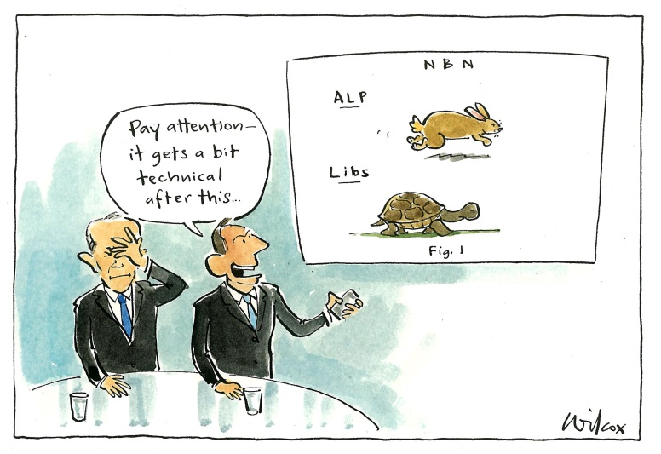 | Cathy Wilcox's "Pay Attention it gets a bit technical after this" is one of Tania’s favourites. What’s your favourite cartoon, let us know on Facebook or #BTL2013  ‘We probably all saw the media coverage of the Coalition's broadband policy launch and this cartoon manages to remind us of what appeared to be extremely awkward moments between Malcolm Turnbull and Tony Abbott. I like the hand gesture, the facial expressions, Tony Abbott's confident delivery and his rabbit and tortoise powerpoint slide. The cartoon is a witty comment on the comedy of manners and Wilcox's use of the pale blue wash in the background and the highlights on the table top also demonstrates her technical confidence.’  - Tania Cleary, Curator.

