# What is a Zine?

A zine (pronounced ‘*zeen*’) is a handmade, self-published magazine, often photocopied and with a limited print run.

A zine can be in black and white or colour and can feature pen and ink, collage, drawing or writing. Zines are highly individual. They are often reproduced on photocopiers.

The word ‘zine’ comes from ‘fanzine’- a magazine set up by science fiction fans in the 1940s as an alternative to the mainstream magazines about celebrities. In the 1980s and 90s zines were often about music. Now they can be about anything. Mostly they reflect whatever their producer feels strongly about.

Zines and newsletter are usually read to be enjoyed, but they’re also used to share strong opinions on society and politicians.

Zines are great for:

* Showing off your knowledge and passion
* Exploring alternatives to mainstream media and contemporary arts
* Exploring artistic ways to express your opinion
* Sharing ideas with a small group, such as family and friends
* Building writing experience
* Adding to a folio for writing, photography or graphic design
* Giving voice to emergent writers and artists

You have a voice, use it! Make a zine.

*Here are some examples of zines from around the internet:*

[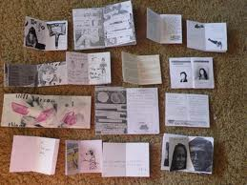](http://www.google.com.au/imgres?start=93&sa=X&rls=com.microsoft:en-au:IE-Address&biw=1280&bih=815&tbm=isch&tbnid=plH_FAp5P8ht9M:&imgrefurl=http://snapdragonzinefair.wordpress.com/&docid=m6BtajmknSFTTM&imgurl=http://snapdragonzinefair.files.wordpress.com/2011/09/p1060045.jpg&w=3168&h=2376&ei=xqwXU_CsHYKWkwWT7YGYCA&zoom=1&ved=0CB4QhBwwBzhk&iact=rc&dur=3056&page=5&ndsp=27)[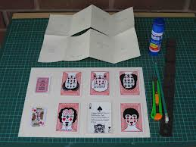](http://www.google.com.au/imgres?start=93&sa=X&rls=com.microsoft:en-au:IE-Address&biw=1280&bih=815&tbm=isch&tbnid=0ghLhVr9LijsWM:&imgrefurl=http://mothwomanpress.blogspot.com/2012/12/poker-faces-zine-part-2-construction.html&docid=r-nfJnZ-KYUuNM&imgurl=http://3.bp.blogspot.com/-DdpjyQNupY8/UMDvz9uta2I/AAAAAAAAGD0/dvSW_teZlcU/s1600/IMG_8236.jpg&w=1600&h=1200&ei=xqwXU_CsHYKWkwWT7YGYCA&zoom=1&ved=0CCEQhBwwCDhk&iact=rc&dur=3447&page=5&ndsp=27)[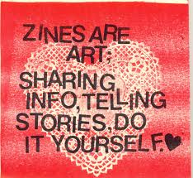](http://www.google.com.au/url?sa=i&rct=j&q=&esrc=s&frm=1&source=images&cd=&cad=rja&uact=8&docid=CAwGUBwG9Y_m1M&tbnid=tiYo4ESxlK5P2M:&ved=0CAUQjRw&url=http://www.grassrootsfeminism.net/cms/node/820&ei=8q0XU9qaOIuPkgWEx4CgCg&bvm=bv.62577051,d.dGI&psig=AFQjCNHYr3DLacQvY-v8w6452M8k-1IUbA&ust=1394146772602663)

’mothwoman press’ snapdragon zine fair’ ‘grassroots feminism.net’

