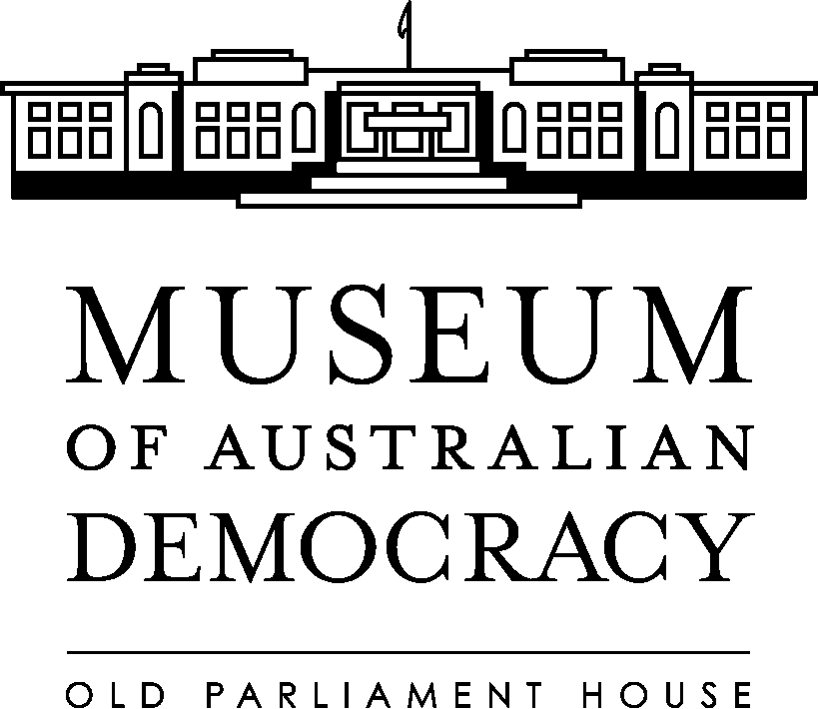

Workplace diversity commitment
The Museum of Australian Democracy at Old Parliament House (the agency) is committed to providing a supportive, inclusive and respectful work environment which recognises and values the diversity of all its employees and visitors.

The agency acknowledges that every employee, regardless of gender, age, ethnicity or cultural background, sexual orientation, disability, religious belief, political affiliation, socioeconomic origin, or family responsibilities can make a valuable contribution to achieving business outcomes.

In addition to the commitment by the agency, all employees have an ethical and legal responsibility to maintain an environment that is safe, respectful and productive. All employees and visitors to Old Parliament House have the right to be treated fairly in an environment that recognises and accepts diversity.
Content, Exhibitions and Events
The agency recognises the diversity of the Australian community and is committed to not only fostering diversity in the workplace, but in developing content, exhibitions and events that acknowledge the diverse democratic views of the Australian community.

The agency is particularly committed to building partnerships with Indigenous Australians to support the development of exhibitions and events that tell the story of Indigenous Australians and the key role Indigenous people continue to play in Australian Democracy.

Our strategy
The agency promotes an environment where fairness and equity is encouraged and supported and where all forms of discrimination, harassment and bullying are eliminated.

We will achieve this objective by:
- Raising awareness of and promoting workplace diversity in the agency.
- Integrating the principles of workplace diversity into business and human resource management policies, practices and systems.
- Engaging with a range of partners external to the agency from a range of diverse backgrounds to assist in the development of content, exhibitions and events.
- Encouraging employees to identify and maximise use of their life skills and experiences in the workplace.
- Encouraging supervisors to recognise and draw on the diversity of their employees.
- Ensuring employees are not subjected to discrimination or unfair treatment in the workplace on grounds such as, ethnicity, race, gender, age, physical or mental disability or personal responsibilities.
- Upholding and promote the APS Values, Employment Principles and Code of Conduct
- Continuing to work towards elimination of all forms of harassment and bullying in the workplace.
- Ensuring employees and those seeking employment with the agency receive fair and equitable treatment in accessing employment opportunities, employees selection processes, career development and mobility arrangements.

