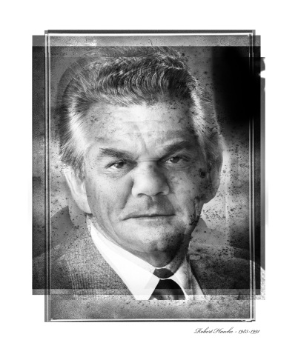
Media Backgrounder: Michael Cook: Through My Eyes

For the first time in Canberra the internationally renowned Australian artist Michael Cook presents an audacious and thought provoking series of photographic works in a temporary exhibition; Michael Cook: Through My Eyes at Old Parliament House. Cook’s visually striking series of portraits layer indigenous faces over portraits of former Prime Ministers, which invite viewers to rethink the way they engage with Australian history. In this exhibition Cook boldly asks; what if? What would life for Indigenous Australians be like now if Australia’s political leaders had been able to view Aboriginal culture through Aboriginal eyes?
For Cook, it’s about learning Australia’s history to create a better future. Through his daring artistic vision he poses the question, “How would a better understanding of Indigenous culture for the past 200 years affect Aboriginal people today?”
Cook’s photographic works are thought provoking. For this remarkable series, he transposed the faces of 19 Aboriginal models from Queensland over the faces of 27 former Australian prime ministers. Cook utilised official prime ministerial portraits held by the National Library of Australia, to create these works.
His photographic practice is highly unorthodox with images constructed in multiple layers, rather like a painting. The result is an unusual and daring interpretation of Australia’s political leaders, which challenges viewers to rethink Australian history from an indigenous perspective. Cook says, “When I produce art I feel a stronger connection with my ancestry. This helps me to understand Australian history and, in particular, my history.”
For Cook, art provides a way of knowing about the past without dwelling on it. He wants his audience to understand Indigenous cultures, and he sees both white and Aboriginal cultures as equal. Through My Eyes builds on a long tradition of bringing difficult and important questions to the steps of Old Parliament House.
Old Parliament House is an icon of Australia’s democracy. Its halls are full of the voices of key thinkers who shaped who we are today. These days, it is dedicated to the voice of the people and helping Australians find their own voice through engaging and transformative experiences. It is a place of great beauty, magnificent design and historical significance.
Michael Cook: Through My Eyes is presented as part of National Reconciliation Week and NAIDOC Week.

Exhibition details: Michael Cook: Through My Eyes
Courtesy of the artist and Andrew Baker Art Dealer, Brisbane
1 May 2014 – 3 August 2014. Open 9am to 5pm
Museum of Australian Democracy at Old Parliament House
For further information and interviews with the artist contact: Greg Parish: Community Engagement Section: 02 6270 8153 or Media@moadoph.gov.au

