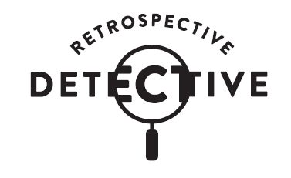

A self-guided, teacher-facilitated learning experience for Years 5 and 6
www.moadoph.gov.au/learning

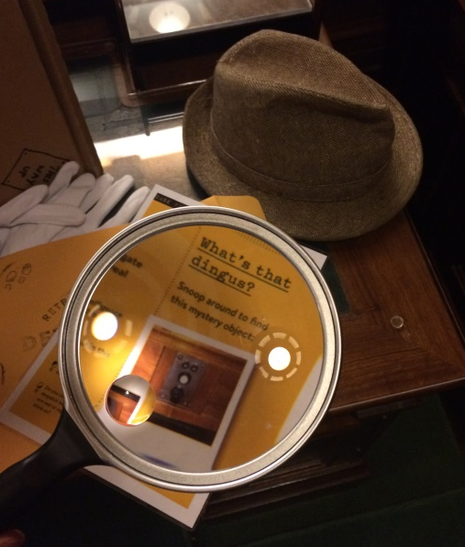

It’s forensic time! Explore the spaces, nooks and crannies of the museum while cracking codes, examining evidence and documenting discoveries. Inspect four key heritage spaces to discover historical facts and mystery objects in a hands-on, teacher-facilitated learning program and report the verdict back at school!

Retrospective Detective: General information

This program is designed for students in Years 5-6
Bookings are essential

Online bookings bookcanberraexcursions.com.au
Email bookings@moadoph.gov.au
Phone (02) 6270 8282

Where can we do Retrospective Detective?

The program is undertaken at the Museum of Australian Democracy (MoAD) at Old Parliament House. The program will direct students through the museum spaces under the supervision of teachers.

What is provided?

• Welcome, program outline and conclusion by MoAD Educator
• Detective Kits for use during the program
• Printed copies of teacher and student case files for use during program
• Copies of museum map for use during program
• Detective notebook for each group
• Museum investigation activities facilitated by teachers and adults accompanying the school

What does it cost?

- 2019 - $3.50 per student
- 2020 - $5.00 per student

How many students can do this program?

Retrospective Detective is designed to be completed in small groups of up to 8 students with at least one accompanying adult per group.

A maximum of 35 students can be accommodated at any one time.

What do I need to do before the program?

Familiarise yourself with the Student’s Case Files, Teacher’s Intelligence Files and the Program Spaces Map.

Session timing

The program duration is 60-90 minutes.

The welcome and orientation is facilitated by MoAD Educators. The main body of the program is self-guided, following instructions provided in the Detective Kit.
Students visit up to four spaces during this time, undertaking activities in each space. The groups are self-paced and it may not be possible to visit all four spaces during the time available.

15-25 minutes
- Welcome and orientation to physical space - facilitated by MoAD Educator

35-50 minutes
- Students carry out program activities, working through four ‘Case Files’ that interrogate the building - facilitated by teachers and adults accompanying the school

10 minutes
- Program debrief – facilitated by MoAD Educator
- Students depart

Learning aims

The program engages students in Australia’s ongoing journey as a democracy, in which they have a role, through:
- Making deductions about significant objects, events and history connected with this former parliamentary building.
- Questioning and considering: What do this building, its history and objects have to do with me? What relevance do the stories, histories and concepts explored at this site hold for me? What contributions can I make to this site, what meaningful conversations can I with my peers during and after my visit here?
- Discovering heritage features and their function in the Chambers where Australia’s Federal Parliament met from 1927-1988.

Strategies

Students will have the opportunity to:
- Engage in a positive and enjoyable museum learning experience whilst applying knowledge and skills relevant to History, Civics and Citizenship and English.
- Encounter stories and objects significant to the development of democracy.
- Engage in collaborative, social learning.
- Develop museum navigation skills.
- Develop skills in historical inquiry.

Experience the heritage and history of an important and iconic building, Old Parliament House.

Australian Curriculum 8.4 Links
Humanities and Social Sciences

Civics and Citizenship

Year 5
- The key values that underpin Australia’s democracy (ACHASSK115)

Year 6
- The key institutions of Australia’s democratic system of government and how it is based on the Westminster system (ACHASSK143)
- The responsibilities of electors and representatives in Australia’s democracy (ACHASSK145)
History

Year 6
- Experiences of Australian democracy and citizenship, including the status and rights of Aboriginal and Torres Strait Islander Peoples, migrants, women, and children (ACHASSK135)
- The contribution of individuals and groups to the development of Australian society since Federation (ACHASSK137)

Inquiry and Skills
Year 5
- Locate and collect relevant information and data from primary sources and secondary sources (ACHASSI095)
- Organise and represent data in a range of formats including tables, graphs and large- and small-scale maps, using discipline-appropriate conventions (ACHASSI096)
- Examine primary sources and secondary sources to determine their origin and purpose (ACHASSI098)
- Examine different viewpoints on actions, events, issues and phenomena in the past and present (ACHASSI099)

- Work in groups to generate responses to issues and challenges (ACHASSI102)

Year 6
- Locate and collect relevant information and data from primary sources and secondary sources (ACHASSI123)
- Organise and represent data in a range of formats including tables, graphs and large- and small-scale maps, using discipline-appropriate conventions (ACHASSI124)
- Examine primary sources and secondary sources to determine their origin and purpose (ACHASSI126)
- Examine different viewpoints on actions, events, issues and phenomena in the past and present (ACHASSI127)
- Work in groups to generate responses to issues and challenges (ACHASSI130)

English

Year 5
- Identify aspects of literary texts that convey details or information about particular social, cultural and historical contexts (ACELT1608)
- Clarify understanding of content as it unfolds in formal and informal situations, connecting ideas to students’ own experiences and present and justify a point of view (ACELY1699)
- Use interaction skills, for example paraphrasing, questioning and interpreting non-verbal cues and choose vocabulary and vocal effects appropriate for different audiences and purposes (ACELY1796)
- Plan, rehearse and deliver presentations for defined audiences and purposes incorporating accurate and sequenced content and multimodal elements (ACELY1700)
- Navigate and read texts for specific purposes applying appropriate text processing strategies, for example predicting and confirming, monitoring meaning, skimming and scanning (ACELY1702)

Year 6
- Understand that strategies for interaction become more complex and demanding as levels of formality and social distance increase (ACELA1516)
- Make connections between students’ own experiences and those of characters and events represented in texts drawn from different historical, social and cultural contexts (ACELT1613)
- Participate in and contribute to discussions, clarifying and interrogating ideas, developing and supporting arguments, sharing and evaluating information, experiences and opinions (ACELY1709)
- Understand how authors often innovate on text structures and play with language features to achieve particular aesthetic, humorous and persuasive purposes and effects (ACELA1518)
- Plan, rehearse and deliver presentations, selecting and sequencing appropriate content and multimodal elements for defined audiences and purposes, making appropriate choices for modality and emphasis (ACELY1710)

