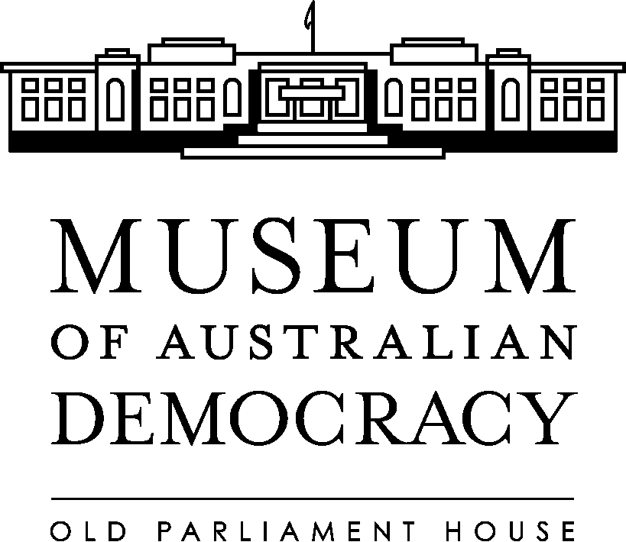

APPLICATION PACK

Reference No: | Shared PN
Title: | Volunteer and Visitor Experience Officer
Classification: | APS Level 5
Job Type: | Non-ongoing for 18months
Hours: | Part–time (40hrs per fortnight)
Salary: | $67,371 – $71,470 (pro-rata) + penalty rates
Team: | Visitor Experience
Security Clearance: | Baseline
Contact Officer: | Brian Leadbeatter (02) 6270 8246
Closing Date: | Midnight – 13 July 2017

Museum Of Australian Democracy At Old Parliament House
Housed in one of Australia’s most prominent national heritage listed buildings, the Museum of Australian Democracy (MoAD) at Old Parliament House was the first museum in Australia dedicated to telling the story of the journey of our democracy. It seeks to provide a range of innovative exhibitions, tours, interpretation, education programs and public activities that will inspire and challenge visitors to explore democracy from its ancient roots to the present day and possible futures.
The Museum of Australian Democracy encourages applications from the diverse Australian community including Aboriginal and Torres Strait Islander people and people with disability, people of all ages and those from culturally and linguistically diverse backgrounds.

About The Position
This position will support the Volunteer and Visitor Experience Coordinator in the day to day operations and supervision of the Visitor Services Officers and Volunteers to meet the museum’s Visitor Experience objectives.

As a member of a team working in conjunction with other sections, the role includes day to day administration of the visitor experience team, including staffing, workflows and rosters, determining daily priorities, mentoring and developing staff and volunteers, and front of house operations including reception.

The occupant of this position will work to a fixed 28 day roster, including regular weekend shifts (two weekends out of every four) and some public holidays. In addition, they may occasionally be required to work overtime to provide assistance outside of their rostered hours.

Duties
Under the supervision of the Volunteer and Visitor Experience Coordinator (APS6):
- Supervise day-to-day front of house operations and coordination of the Visitor Experience team to achieve visitor experience objectives. Duties include briefing Visitor Services Officers (VSO); rosters; identifying and resourcing daily priorities; and responsibility as the senior officer on site on weekends and public holidays, where rostered.

- Maintain VSO and volunteer rosters, records and database, and arrange and organise VSO and volunteer related meetings and events.

- Assist with the development and implementation of training programs for the Visitor Experience team, including volunteers.

- Actively participate in the review, development and implementation of public programs, including performance of associated administrative duties. This may involve taking a leadership role in project teams.

- Maintain effective communication with VSOs, volunteers, other teams, contractors and tenants, using a variety of information channels.

Key Attributes

- Demonstrated experience in supervising staff and volunteers including developing rosters and managing workflows in an environment with competing priorities.

- Demonstrated ability in using the Microsoft Office suite and experience with booking systems, POS systems, volunteer management and roster programs would be an advantage.

- High-level customer service, communication and interpersonal skills. This includes the demonstrated ability to deliver tours and other presentations to visitors and to also deliver training programs for staff and volunteers.

- Demonstrated project management skills and an understanding of the importance of providing authentic, engaging public programs for visitors to a national cultural institution located in a heritage building.

Your application
Please provide a concise statement of no more than two pages outlining your relevant skills and experience.

No selection criteria is required to be addressed, however when framing your response, please ensure you adequately address the position requirements.

Application details
Your application must include:

- A completed application cover sheet - (available on the MoAD website)
- Concise statement of claims.
- Resume outlining your career history, qualifications and contact details for at least two recent referees.

Diversity and Inclusion
MoAD encourages applications from the diverse Australian community including Aboriginal and Torres Strait Islander people and people with disability, people of all ages and those from culturally and linguistically diverse backgrounds.

We will accommodate all requests for reasonable adjustment for people with disabilities to assist in the application process and if successful, the inherent requirements of the position.

If you have an individual requirement that needs to be accommodated in order to participate in an interview, please indicate this on your application cover sheet or advise the contact officer.

Eligibility
Employment with the Museum of Australian Democracy is subject to the following conditions:

Citizenship – To be eligible for employment with MoAD, applicants must be an Australian Citizen.

Security Clearance – The successful applicant will be required to undergo an Australian Government Security Clearance and maintain it at the baseline level. Further information about security clearances can be found on the Department of Defence website at www.defence.gov.au/agsva

Working with Vulnerable People Card – The successful applicant must secure and maintain certification within two months of commencement.

If the security clearance or WwVP check are not maintained or return a negative report at any time, this will be grounds for termination of employment.

Employment Agreement
All terms and conditions for employment at MoAD can be found in the Old Parliament House 2011-2014 Enterprise Agreement

Submission
Preference for submission of applications is electronic. We will accept applications submitted by post.
recruitment@moadoph.gov.au

Applications will not be acknowledged upon receipt.

We will not accept applications received after the closing date, unless an agreement has been made with the contact officer.

